EXTENSION: Gold and its Alloys

Although gold is sold as 22 carat, 18 carat, 14 carat and 9 carat, none of these are pure. Pure gold is said to be 24 carat. Twenty two carat gold is 22 parts gold and two parts other metals. The lower the carats, the less gold is present. White gold differs from yellow gold by having different metals mixed with the gold.  This table shows the percentages by mass of some of these different golds. In other words 100g of 9 carat yellow gold contains 37.5g of metallic gold. | 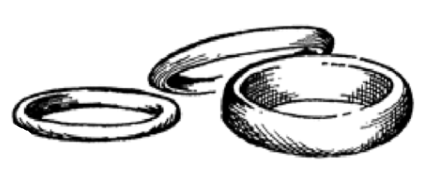

Alloy | Gold (%) | Silver (%) | Copper (%) | Zinc (%) | Nickel (%) | Palladium (%)
9 carat yellow | 37.5 | 10 | 45 | 7.5 | 0 | 0
9 carat white | 37.8 | 0 | 40 | 10.4 | 11.8 | 0
18 carat yellow | 75 | 16 | 9 | 0 | 0 | 0
18 carat white | 75 | 4 | 4 | 0 | 0 | 17
22 carat yellow | 91.7 | 5.5 | 2.8 | 0 | 0 | 0

- What is the general term for a mixture of metals?
- What do all of the metals used in the different golds have in common?
- How much gold is there in 14 carat gold?
- What is the difference between 9 carat gold?
- Some people are allergic to nickel. Why is 9 carat white gold not used in jewellery?
Here are the percentages by volume in 9 carat yellow and white gold. In other words only 22% of the volume of 9 carat yellow gold is metallic gold.

Alloy | Gold (%) | Silver (%) | Copper (%) | Zinc (%) | Nickel (%)
9 carat yellow | 22 | 11 | 56 | 12 | 0
9 carat white | 21 | 0 | 48 | 16 | 14

- Why are these numbers different to those in the first table?
- Why do you think that people buy 9 carat gold?

